Cluster Scoped Access to ADLS gen2

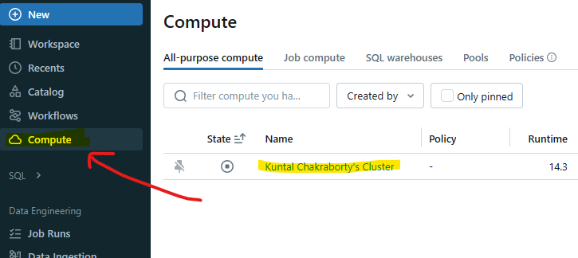

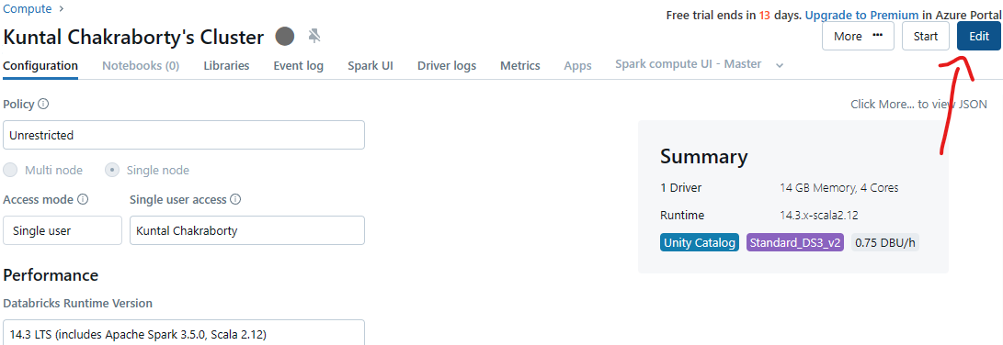

Then Go down to see below senario

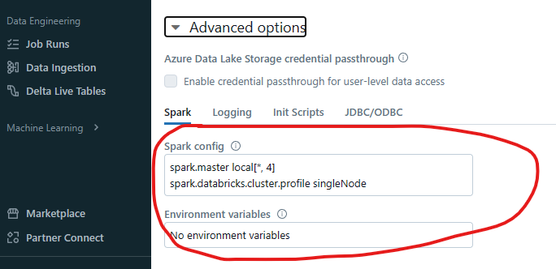

Here in key value pairs command are passed, similarly we need to pass the key and access key of the storage in key value pairs

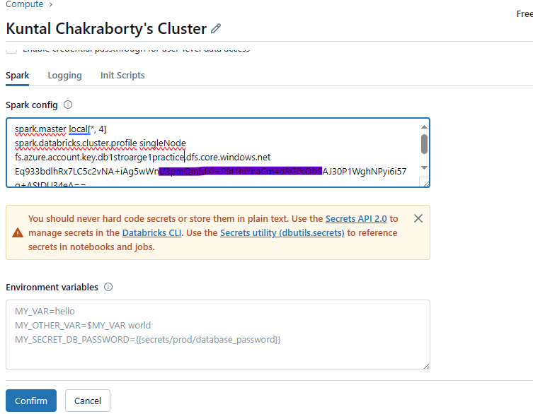

fs.azure.account.key.db1stroarge1practice.dfs.core.windows.net Eq933bdlhRx7LC5c2vNA+hsdjkdjhjka +AStDU34eA==

One space is required here